SOMASTREAM
Cinematic Kajabi
Course Theme
INSTALLATION • CUSTOMIZATION • FEATURE GUIDE


SomaStream product artwork — designed for premium on-demand learning.
VERSION  1.0.1 | PLATFORM  Kajabi Products | EDITION  Advanced Theme

— 01 / SOMASTREAM GUIDE

Start here
A fast, safe installation path for a production Kajabi course.

What this package is
SomaStream is a production-ready Kajabi Product theme with a cinematic member home, flexible module journeys, premium lesson pages, native Kajabi progress and strong mobile navigation. The brand shown in this guide is a starter identity; every major color, font, label and layout is editable in Kajabi.
PACKAGE TO UPLOAD
Upload nova-learning-kajabi-theme-1.0.1.zip exactly as supplied. Do not unzip it, rename internal folders, or add another directory level.

Install in three steps
01 Upload  Products → your course → Customize → Install Template. Choose the supplied ZIP. | 02 Activate  When Kajabi finishes processing, open the new theme and set it as the active template.
03 Brand  Set the four global colors, body/heading fonts, H1–H3 sizes, logo and navigation. | 04 Verify  Test home, Categories, Category, lesson, search and mobile navigation with a real member.

Recommended setup order
- Global Settings → four-color system → typography → logo/favicon.
- Header → navigation, search, announcement popup and announcement bar.
- Product → hero layout, homepage layout, favourites and Explore More action.
- Categories and Category → choose Cinematic Journey or Classic NOVA Grid independently.
- Lesson/Post → test video, audio, downloads, complete, save, Previous/Next and Categories switcher.
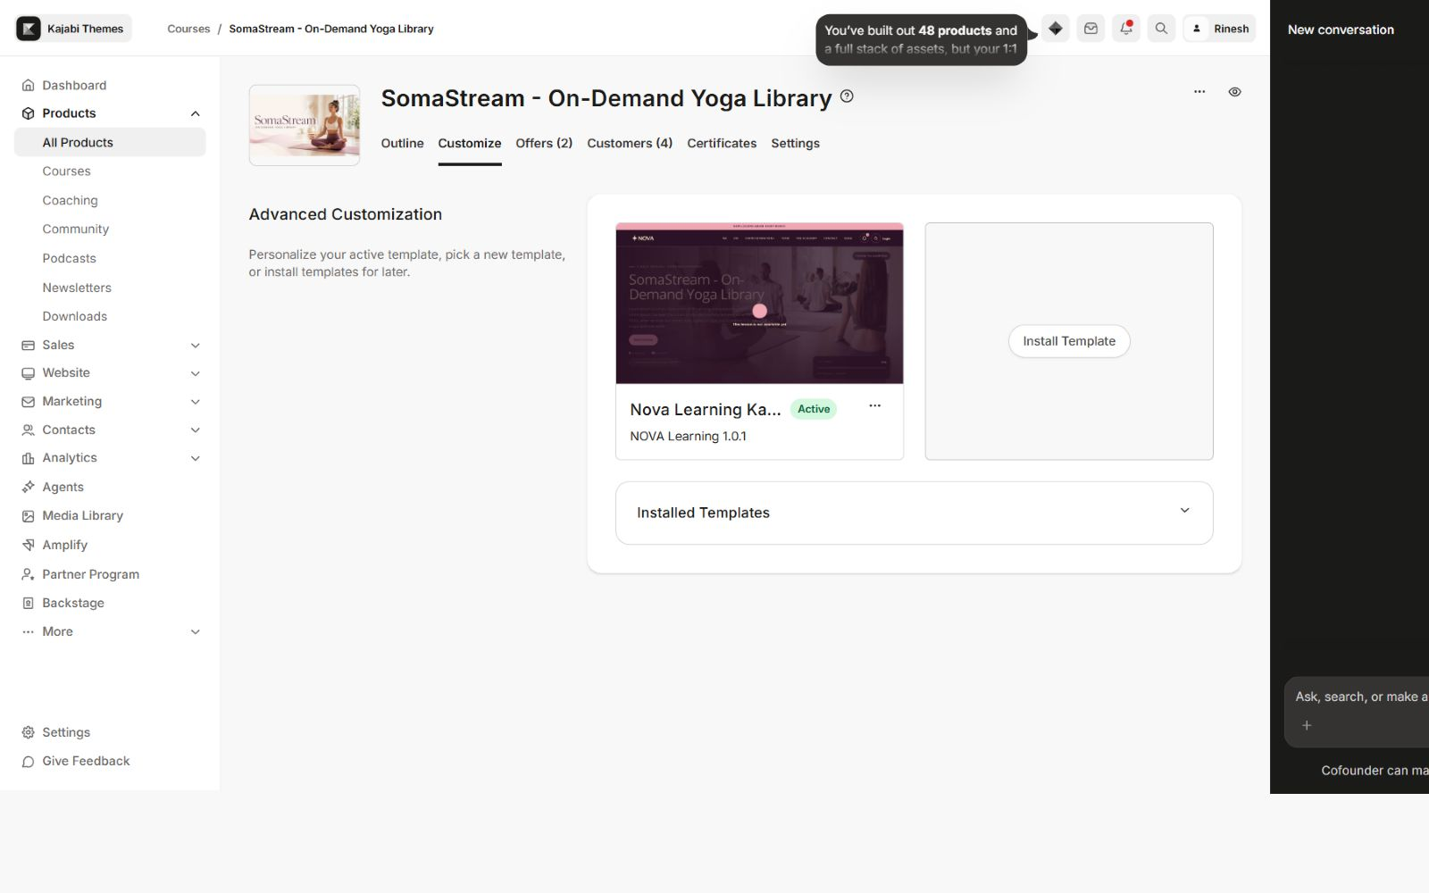
Kajabi theme management: open Customize, then edit the active SomaStream theme.

— 02 / SOMASTREAM GUIDE

Feature map
Everything included in the theme, grouped by the member journey.
Area | What members get | Backend control
Product home | 5 hero designs, 3 syllabus layouts, progress, favourites, featured modules | Independent layout selectors and visibility controls
Categories | Course overview, module cards, progress and locked/drip states | Cinematic Journey or Classic NOVA Grid
Category | Breadcrumbs, module progress, Up Next and compact lesson journey | Cinematic Journey or Classic NOVA Grid
Lesson | Video/audio, downloads, comments, assessment, save and completion | Native Kajabi content plus editable labels
Navigation | Desktop header, search, announcements and mobile bottom navigation | Visibility, link lists and label controls
Community | Optional embedded Kajabi community experience | Off by default; width and height controls
Brand system | Consistent background, surfaces, text and actions | 4 colors, 2 font families, direct px sizes
Access states | Clear lock, paywall, drip and schedule presentation | Unavailable cards remain non-clickable

Kajabi-native behavior retained
- Start/resume learning, course and lesson progress, completion and saved lessons.
- Comments, assessments, downloads, downloadable MP3 resources and announcements.
- Search, member menu, product access, category paywalls, locks and drip schedules.
- Context-aware editor IDs so visible blocks and sections open the correct Kajabi setting.
DEFAULT EXPERIENCE
Featured Categories is the default product-home layout. Cinematic Journey is the default on Categories and Category pages. The standalone Community Widget is off by default.

— 03 / SOMASTREAM GUIDE

Global brand system
Build a lighter or darker identity without chasing colors across individual sections.
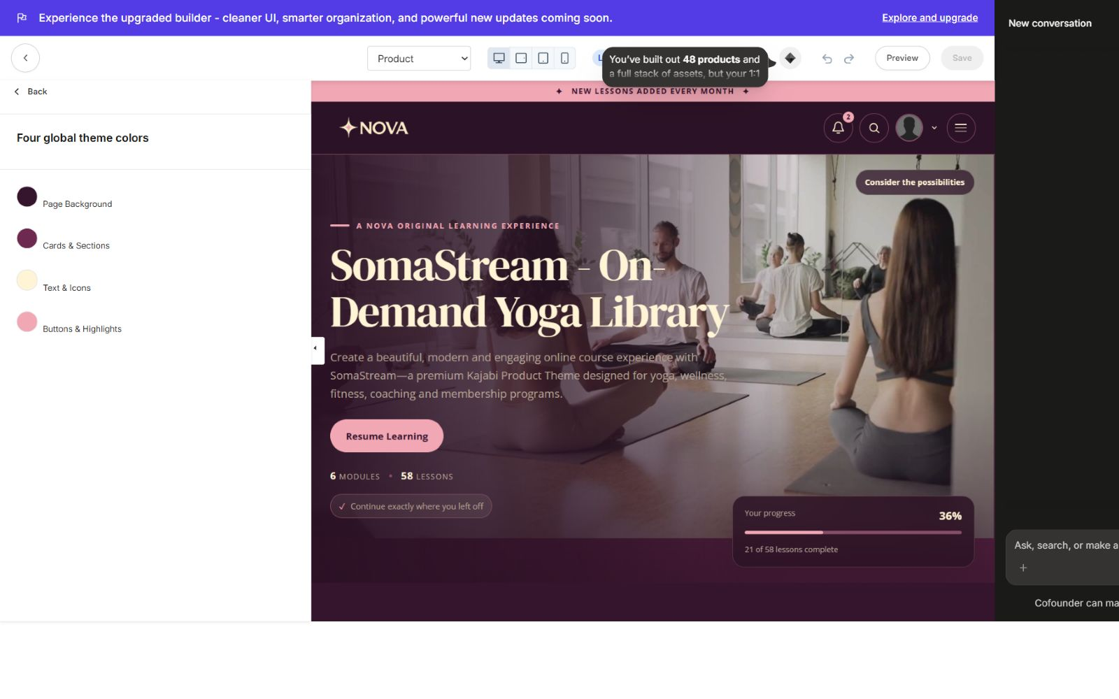
Four global colors control the page, cards, typography and primary actions.
Page Background  The dominant canvas behind the complete member experience. | Cards & Sections  Surfaces for cards, panels, module blocks and lesson outlines.
Text & Icons  Primary readable color for headings, copy, icons and controls. | Buttons & Highlights  Actions, progress emphasis, badges, dots and active states.

STARTER PALETTE
Page #35152D • Surface #6D294F • Text #FFF4D6 • Action #F2A7B5. For a lighter edition, start by brightening Page and Surface while preserving contrast.

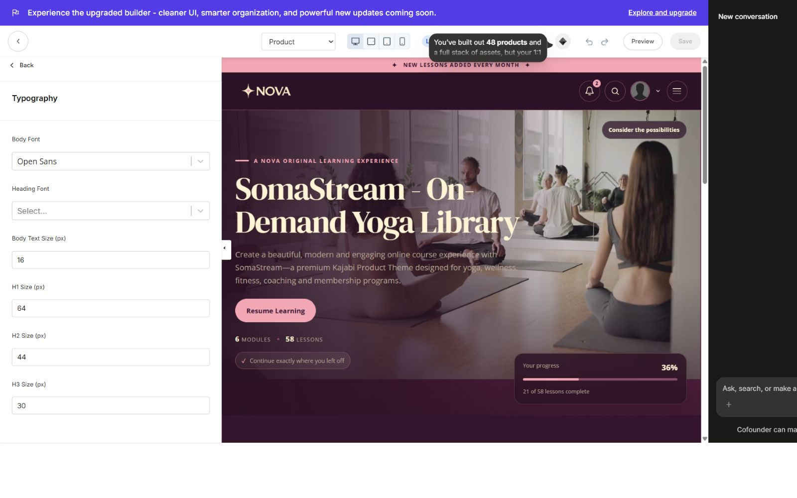
Typography supports separate body and heading families plus direct Body, H1, H2 and H3 pixel controls.
Mobile typography is protected with responsive safety caps, so large desktop headings remain readable and do not overflow smaller screens.

— 04 / SOMASTREAM GUIDE

Product Home — hero banner
Choose one of five cinematic entry points without changing course content.
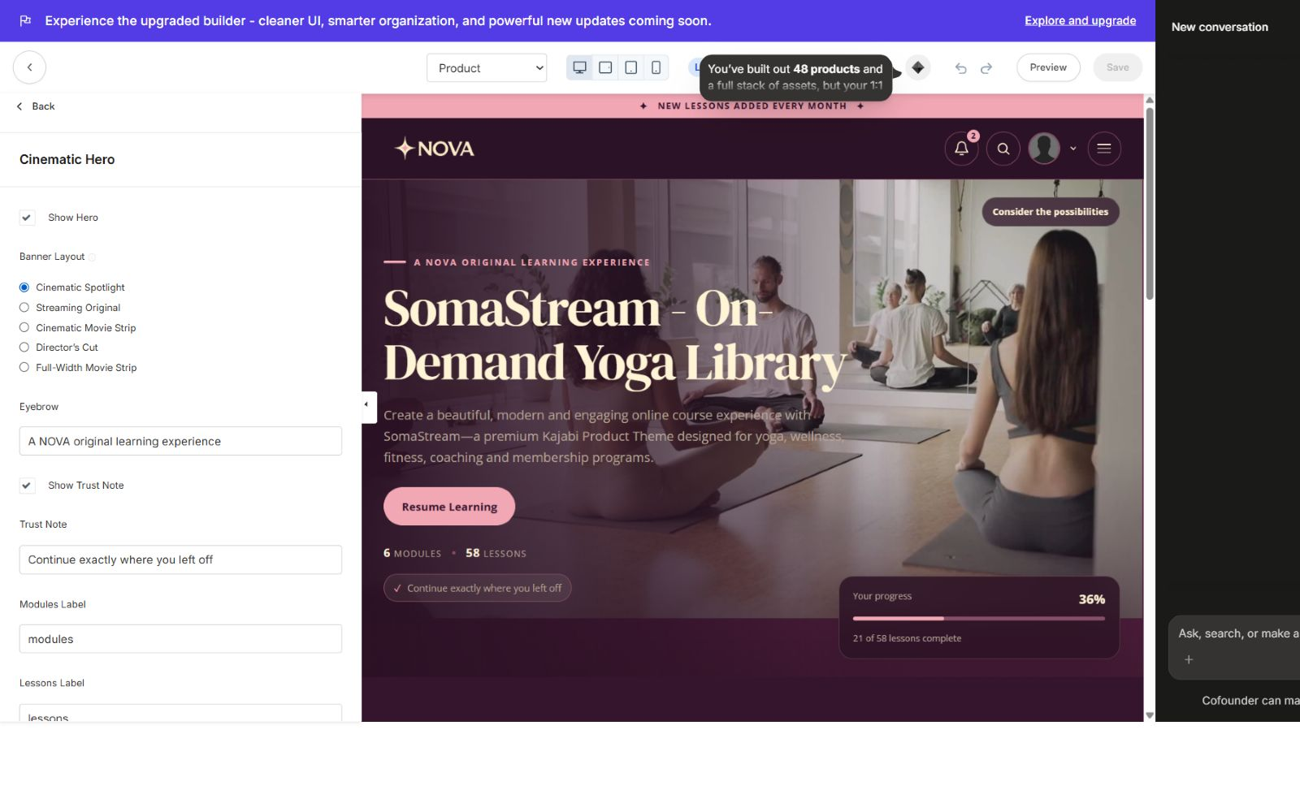
The Product Hero panel exposes five selectable banner layouts and supporting content controls.
Cinematic Spotlight  Large immersive image/video with course copy, Resume Learning and progress. | Streaming Original  Editorial streaming-style hero with stronger content framing.
Cinematic Movie Strip  Wide movie-strip composition for a premium library feel. | Director’s Cut  A more curated poster-and-story presentation.
Full-Width Movie Strip
Maximum-width visual emphasis for cinematic imagery.

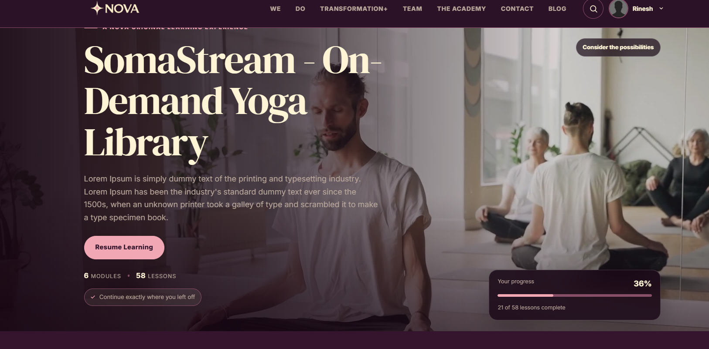
Member view: hero banner, course stats, Resume Learning and overall progress.
EDITABLE HERO CONTENT
Show/hide hero, eyebrow, title/description source, trust note, module and lesson labels, locked label, video tint, product information, Start/Resume blocks and progress display.

— 05 / SOMASTREAM GUIDE

Product Home — course discovery
Select the home structure that best matches the size and style of the library.
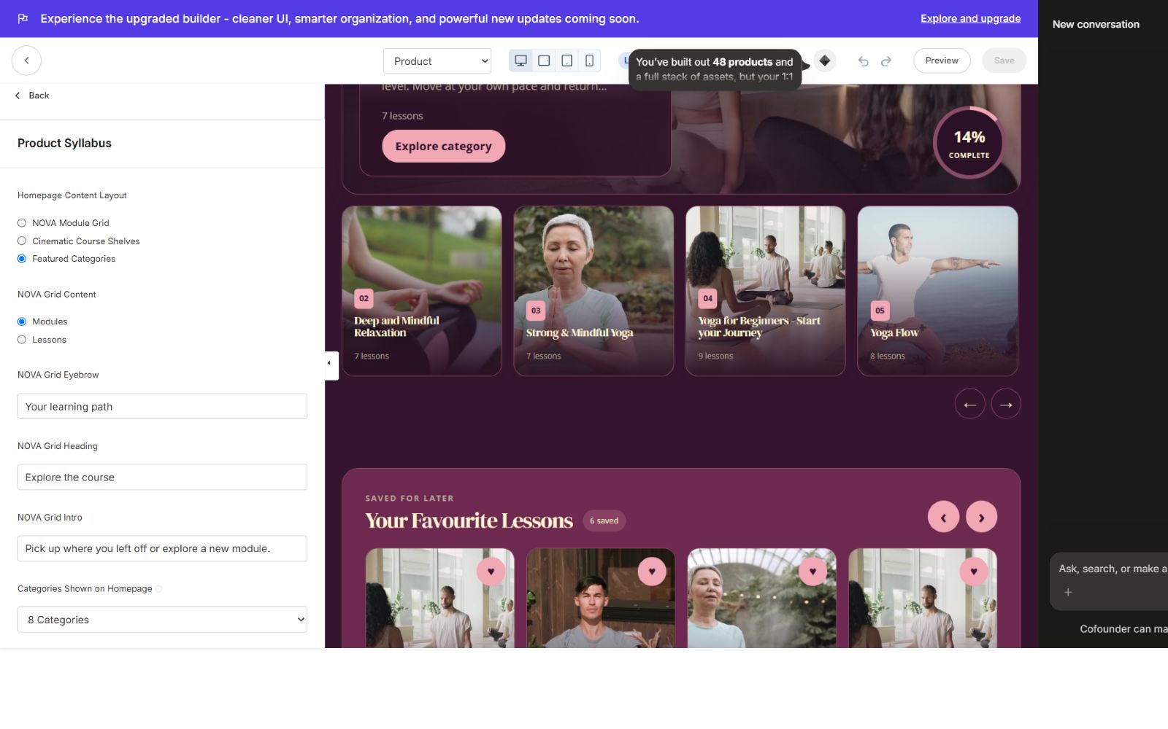
Product Syllabus controls: three layouts, item limits, Explore More action and favourites visibility.
Featured Categories — default  A lead category feature with editorial hierarchy, supporting cards and an Explore More action. | Cinematic Course Shelves  Module shelves with a large feature card, lessons, carousel controls and progress.
Classic NOVA Module Grid
A clean grid for compact course browsing; favourites can remain independently visible.

Favourites slider
Saved lessons appear in a premium horizontal slider with arrow navigation, swipe/scroll support and a progress indicator. Visibility is independent for supported homepage layouts, including the NOVA Module Grid.
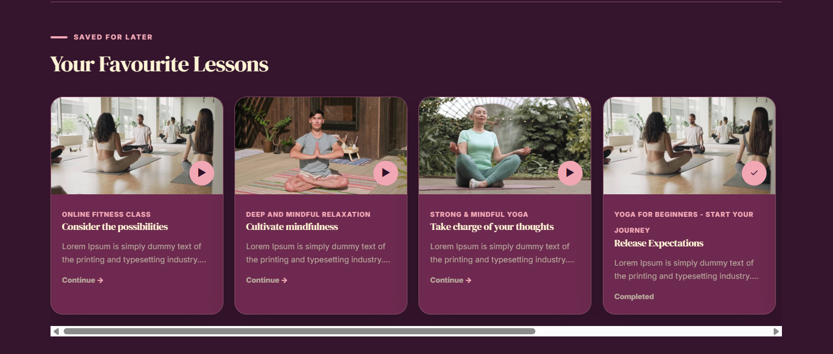
Your Favourite Lessons slider: arrows, saved states, completion states and scroll progress.

— 06 / SOMASTREAM GUIDE

Header, search & announcements
Keep course discovery and member communication available throughout the product.
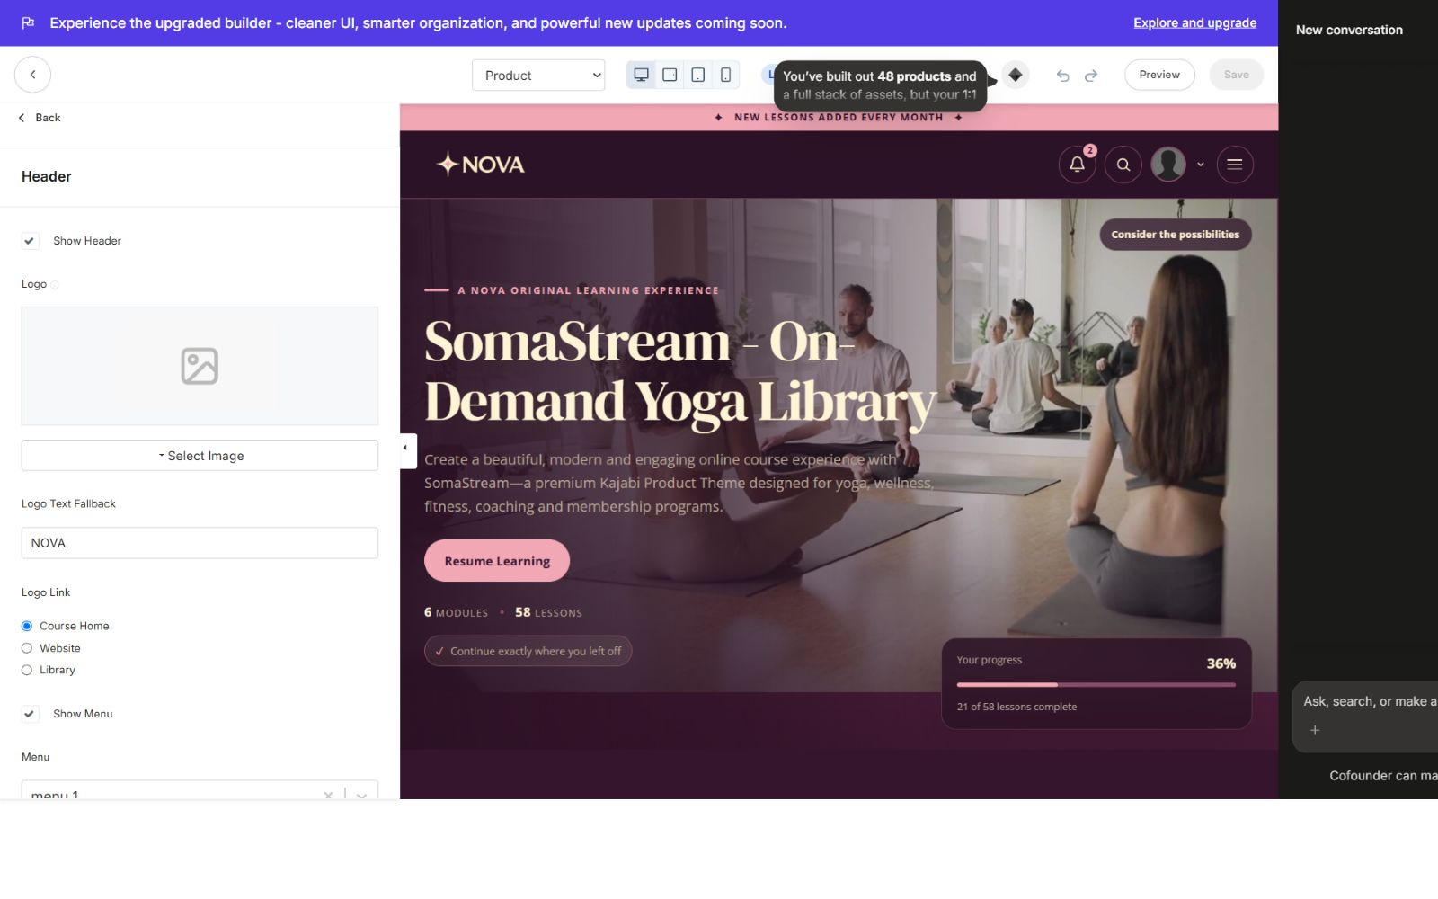
Header controls for logo, links, search, member menu, announcement popup and announcement bar.
- Logo image or editable text fallback, with Course Home, Website or Library link destinations.
- Configurable Kajabi link list for desktop navigation.
- Search can be shown or hidden independently.
- Announcement bar and popup are separate controls with editable titles, empty-state copy and View All label.
- Member menu remains accessible from the branded header.
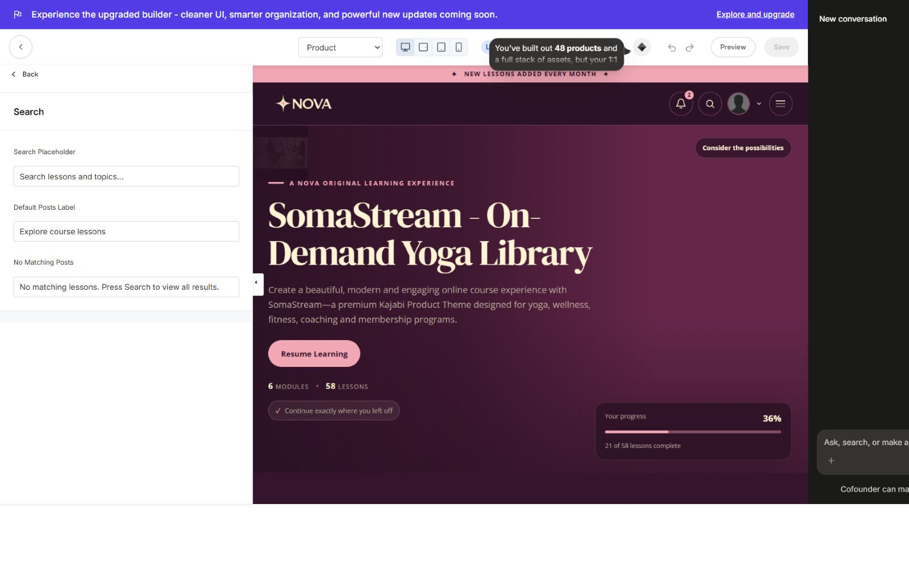
Search copy controls: placeholder, default suggestion label and no-results message.
SEARCH BEHAVIOR
The popup opens with existing course posts already visible. As the member types, the list filters live; they are never greeted by an unnecessarily empty search panel.

— 07 / SOMASTREAM GUIDE

Categories page
A course-level map of every module, with progress and access states.
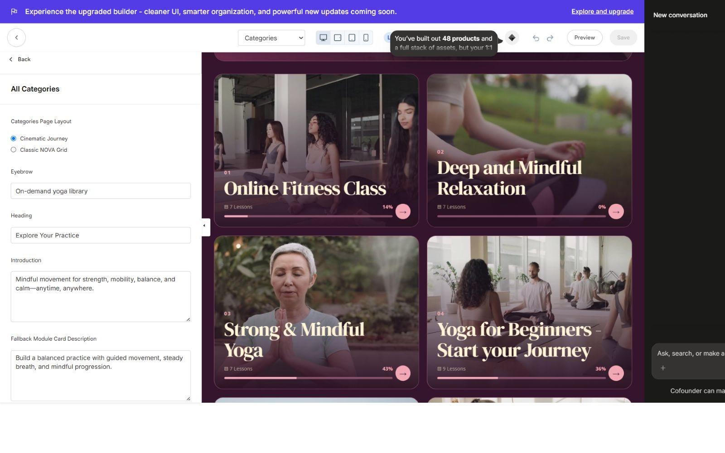
Categories Page Layout: Cinematic Journey or Classic NOVA Grid, plus editable labels and fallback copy.
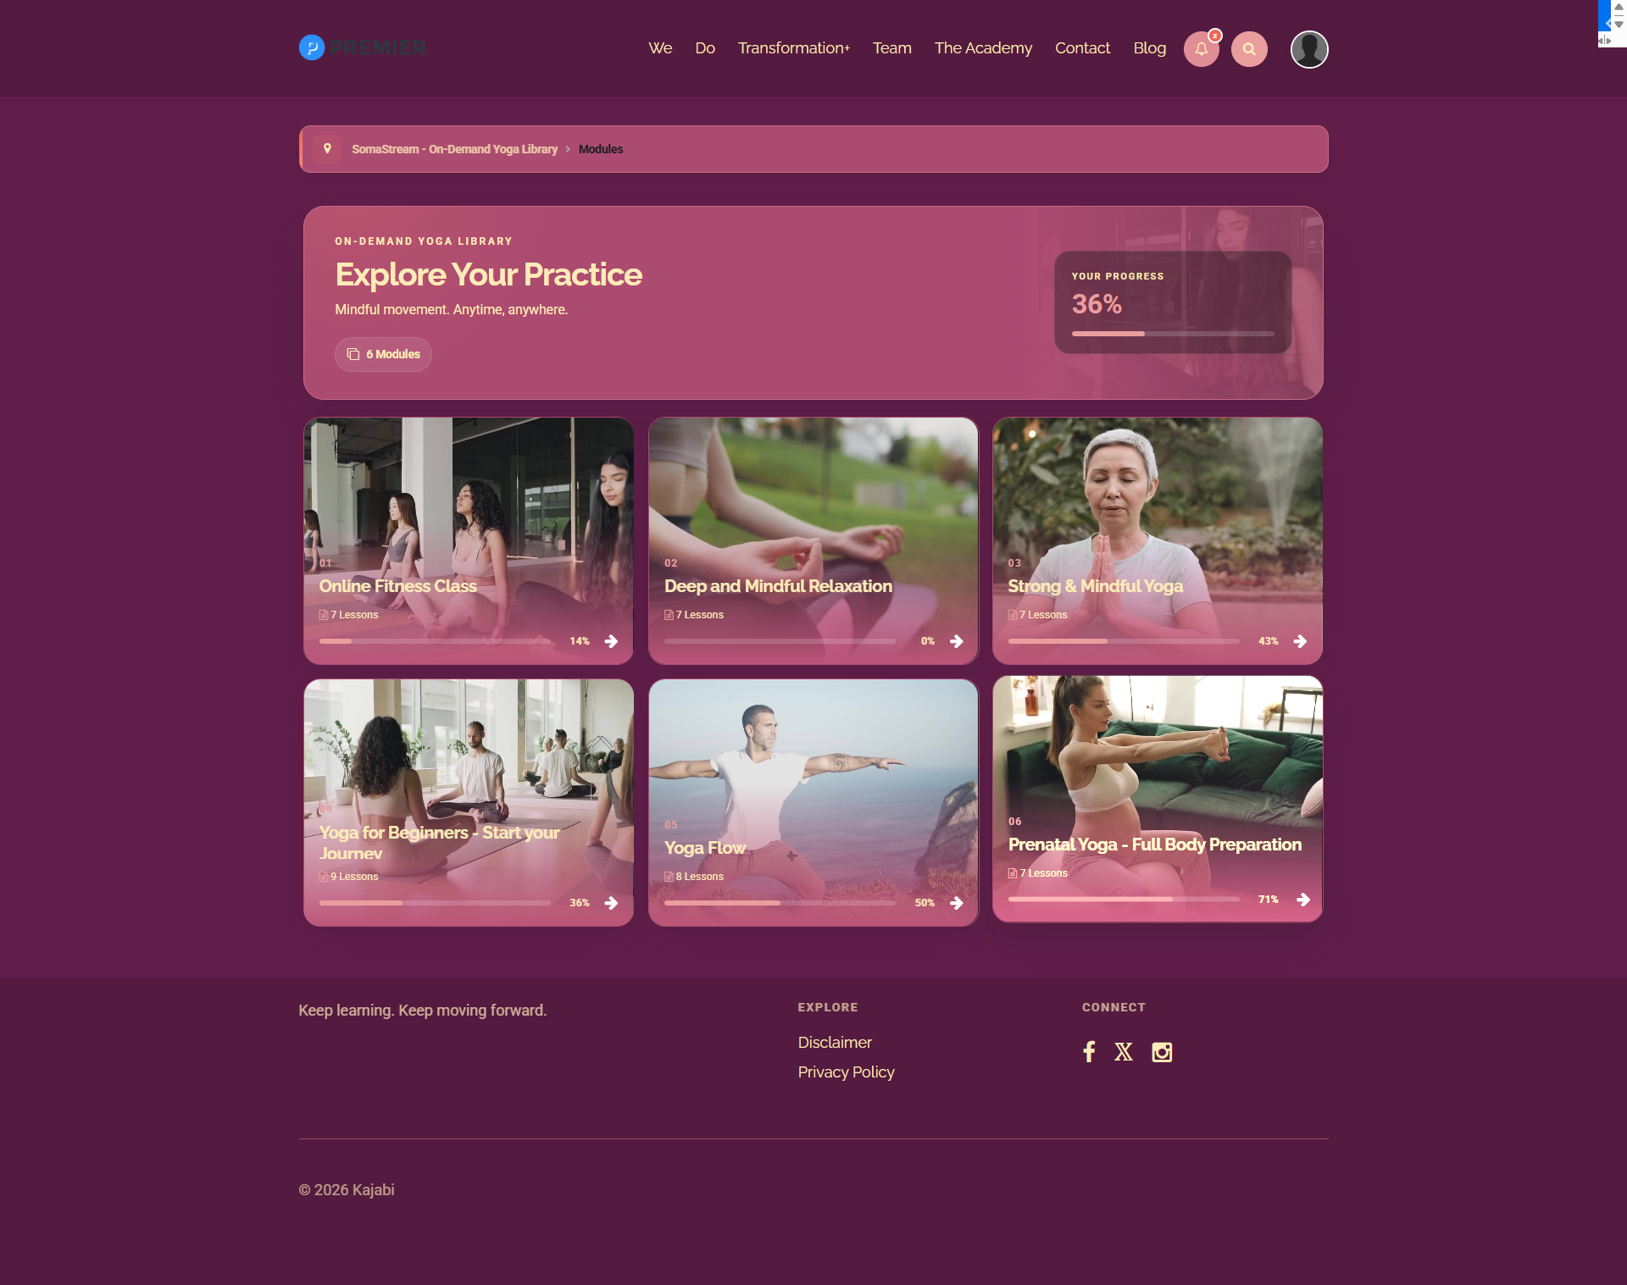
Cinematic Journey structure: course summary, overall progress and visual module cards.
- Default: Cinematic Journey. Classic NOVA Grid remains available as an independent option.
- Module numbers, lesson totals and progress are pulled from Kajabi.
- Locked/paywalled modules show a lock icon; scheduled/dripped modules show a calendar-clock icon.
- Unavailable modules stay visually clear and non-clickable.
- Editable eyebrow, heading, introduction, progress, lesson and locked labels.

— 08 / SOMASTREAM GUIDE

Category page
A focused module journey with a featured next lesson and compact supporting grid.
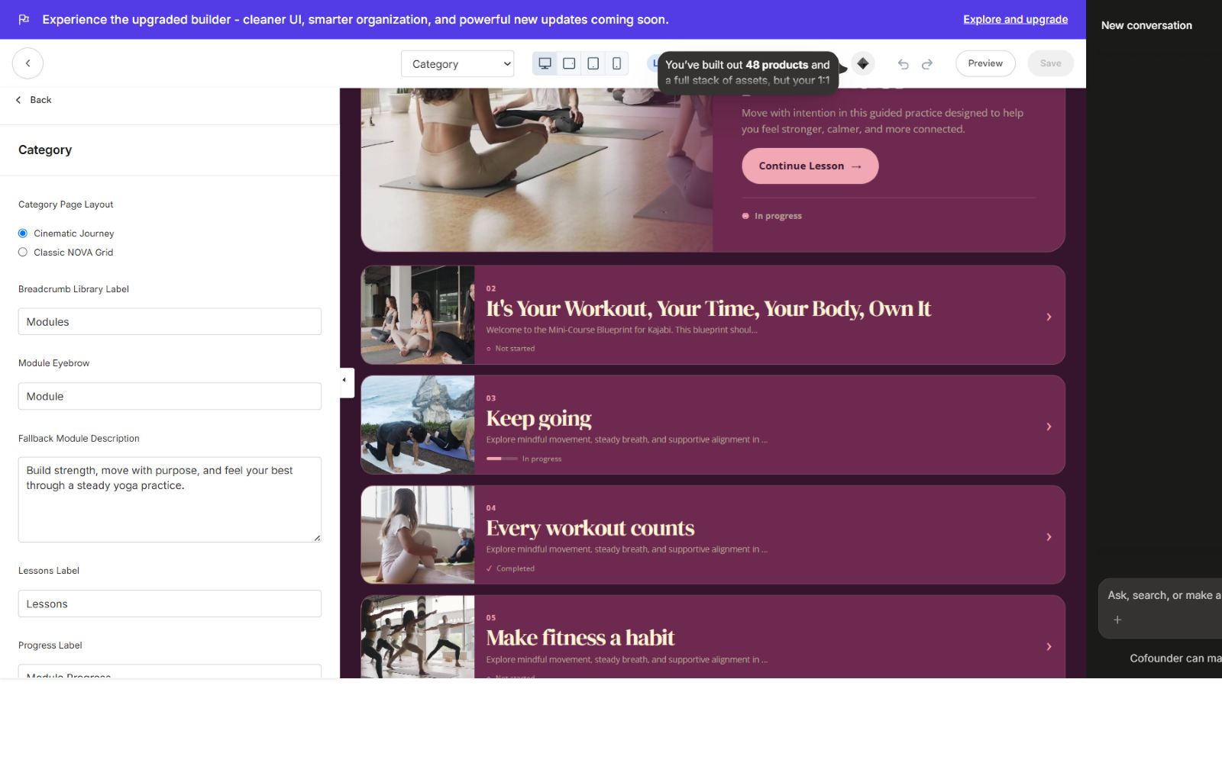
Category Page Layout: Cinematic Journey or Classic NOVA Grid with full label and fallback controls.
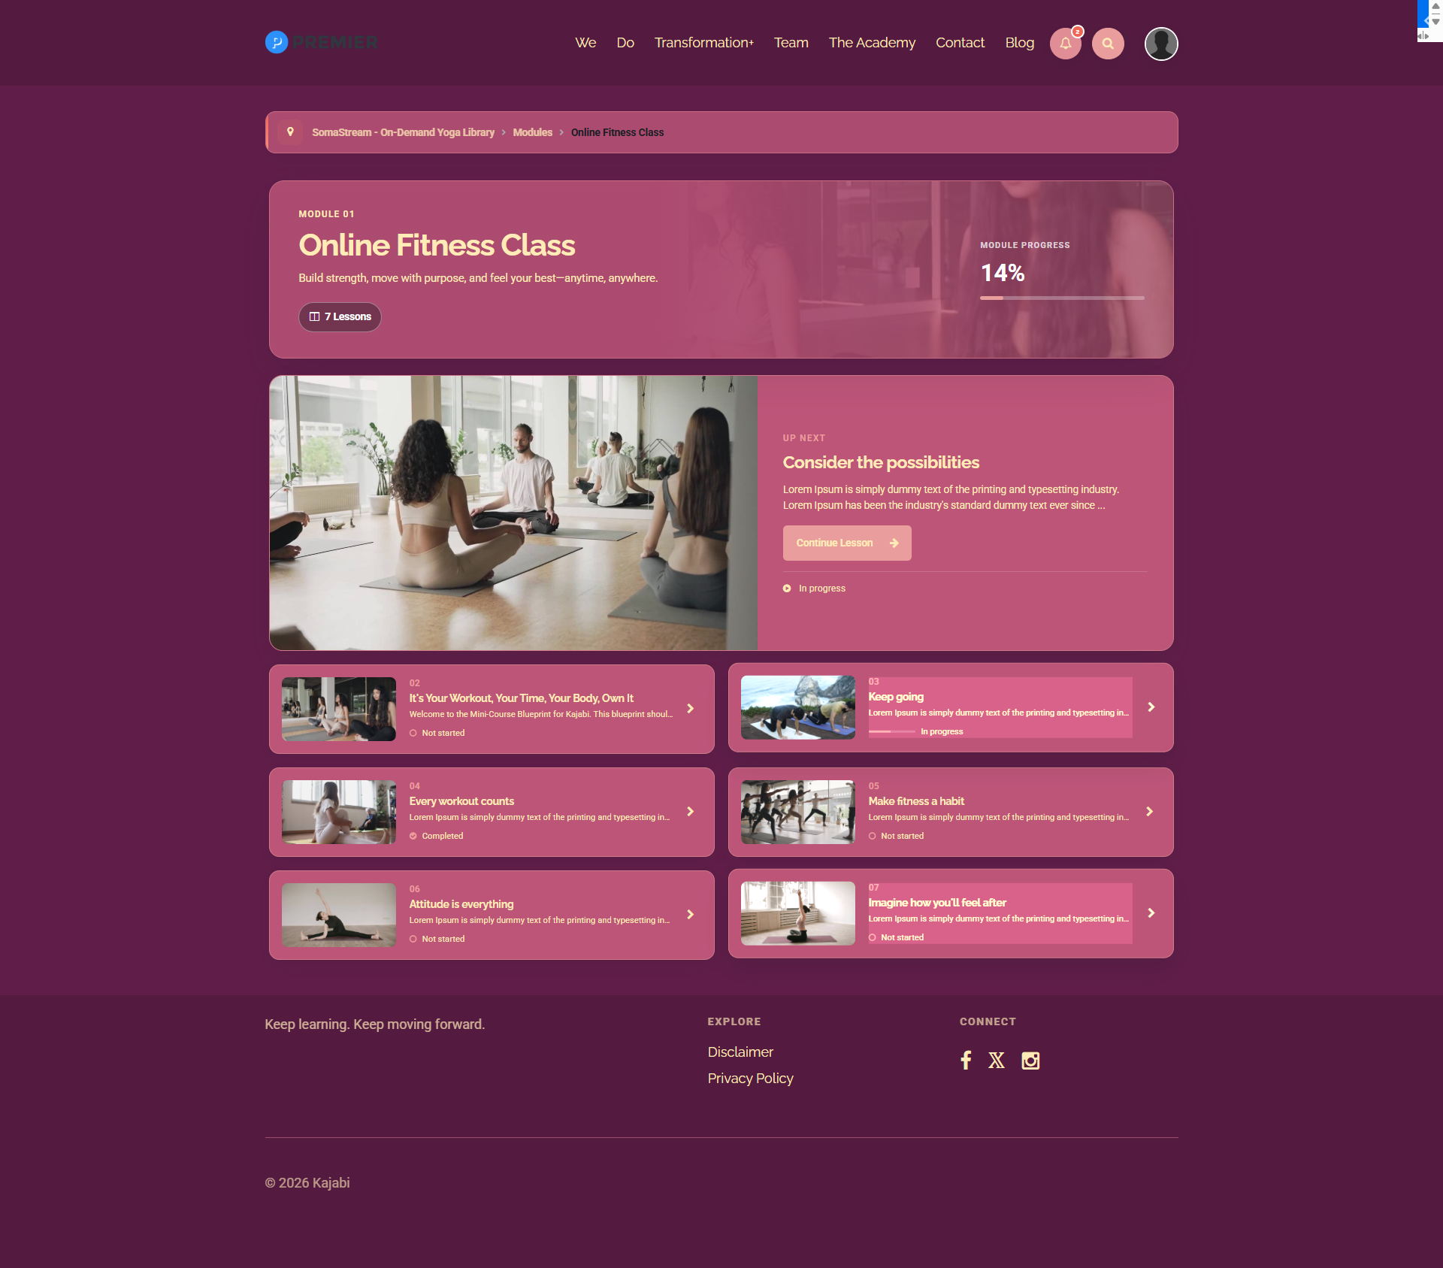
Category structure: breadcrumb, module hero/progress, Up Next lesson and compact lesson cards.
- Course → Modules → current module breadcrumb.
- Module summary with lesson total and progress bar.
- Featured Up Next lesson with image, description, status and Continue Lesson action.
- Compact two-column lesson journey for remaining posts, plus pagination when required.
- Subcategories are supported and use their own editable heading.
- Dummy placeholder copy is replaced by editable yoga fallback text; real Kajabi copy always wins.

— 09 / SOMASTREAM GUIDE

Lesson experience
A focused player with familiar course context and complete Kajabi learning actions.
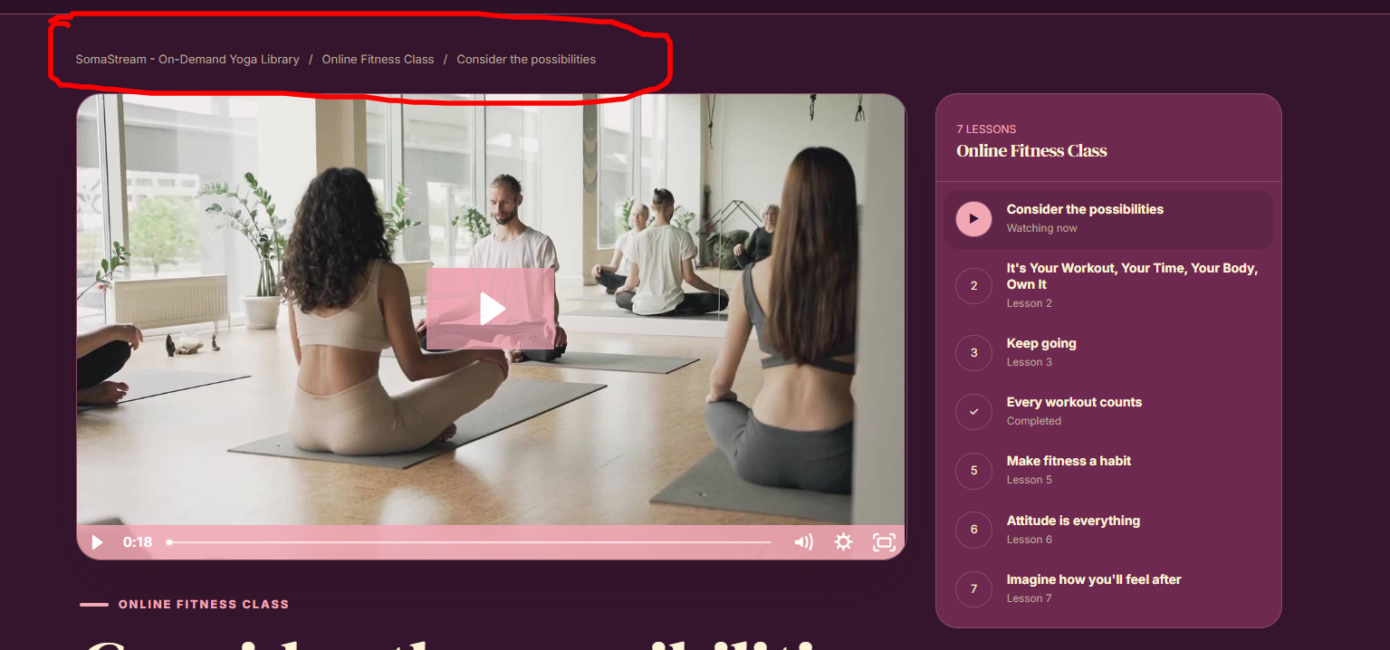
Lesson page: styled breadcrumb, media player and current category outline.
Media  Video player, native audio/MP3 presentation and lesson body content. | Learning actions  Complete Lesson, Saved state, comments and Kajabi assessments.
Resources  Download cards for Kajabi files, including downloadable MP3 resources. | Navigation  Previous/Next lesson actions plus a Categories switcher at the outline footer.

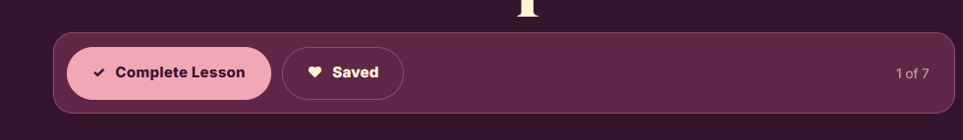
Previous and Next controls sit beside completion, saved status and the current lesson count.
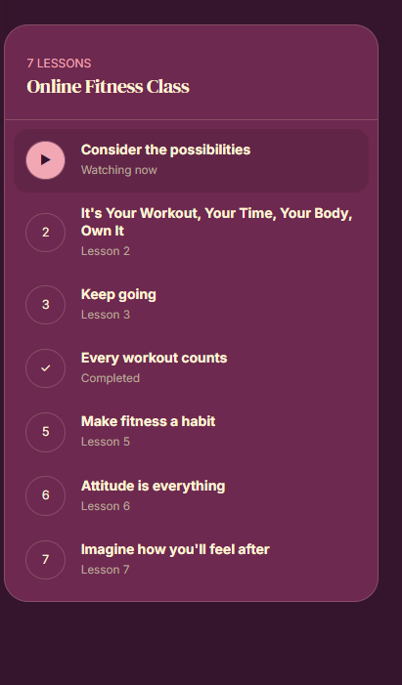
Desktop lesson outline includes a Categories action so members can switch modules at any time.
ACCESS-SAFE STATES
Locked, paywalled, scheduled and dripped lessons use clear iconography and messages. Unavailable destinations do not behave like normal clickable lesson cards.

— 10 / SOMASTREAM GUIDE

Mobile member experience
Persistent navigation and context-aware slide-up panels on small screens.
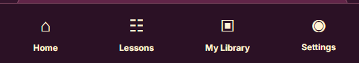
Mobile bottom navigation appears across course pages: Home, Lessons, My Library and Settings.
- Home returns to the current product home.
- Lessons opens the current category’s posts while viewing a lesson.
- On other course pages, Lessons opens the category/module list.
- The lesson slide-up includes a bottom Categories button that opens the same category switcher.
- My Library and Settings remain one tap away.
- Favourites shelves and other horizontal collections support touch swiping.
RESPONSIVE DESIGN
Layout, card widths and typography adapt automatically; direct desktop font sizes are capped safely on mobile to prevent clipping and overflow.

— 11 / SOMASTREAM GUIDE

Community & Welcome Body blocks
Add supporting content without hard-coding a second homepage.
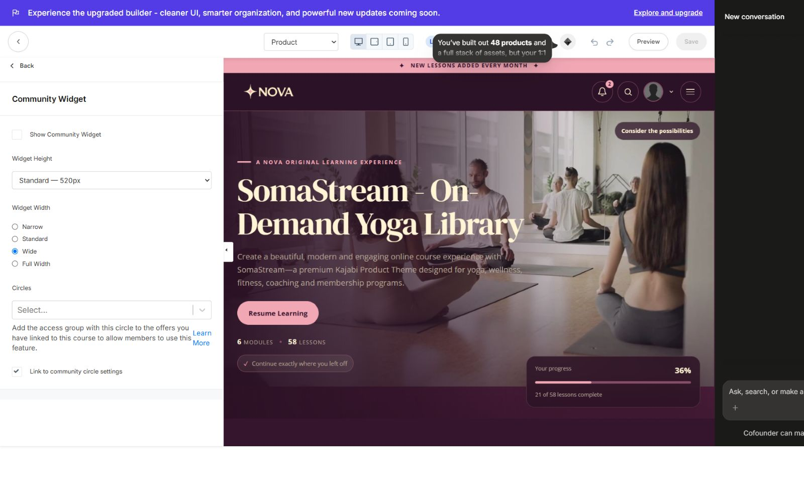
Standalone Community Widget: off by default, with compact-to-tall heights and narrow-to-full widths.
- Show/hide the Community Widget independently; default is Off.
- Choose 360, 440, 520, 640, 760 or 900 px height presets.
- Choose Narrow, Standard, Wide or Full Width container sizing.
- Select the Kajabi Circle and ensure the connected offer grants access.
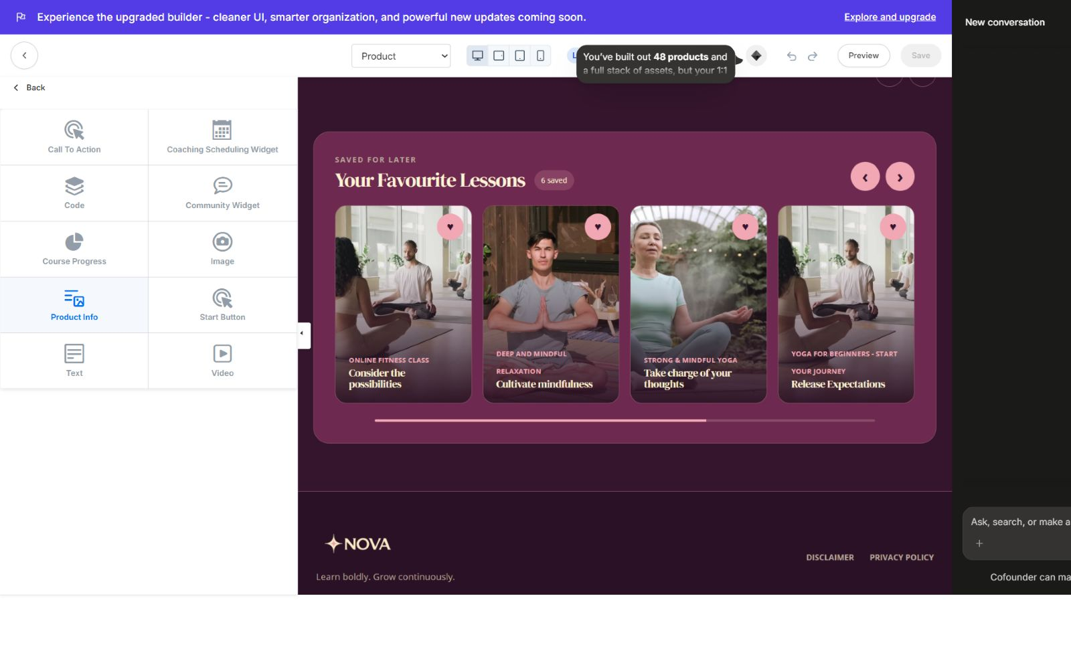
Welcome Body block library, including Community Widget alongside native content blocks.
Content blocks  Text, Image, Video, Product Info, Course Progress and Start Button. | Action blocks  Call To Action and Coaching Scheduling Widget.
Advanced blocks  Code and Community Widget for custom or connected experiences. | Layout controls  Each supported block can use 1–12 columns to control desktop width.

— 12 / SOMASTREAM GUIDE

Footer, copy & editor integration
Finish the experience with consistent navigation and easily editable language.
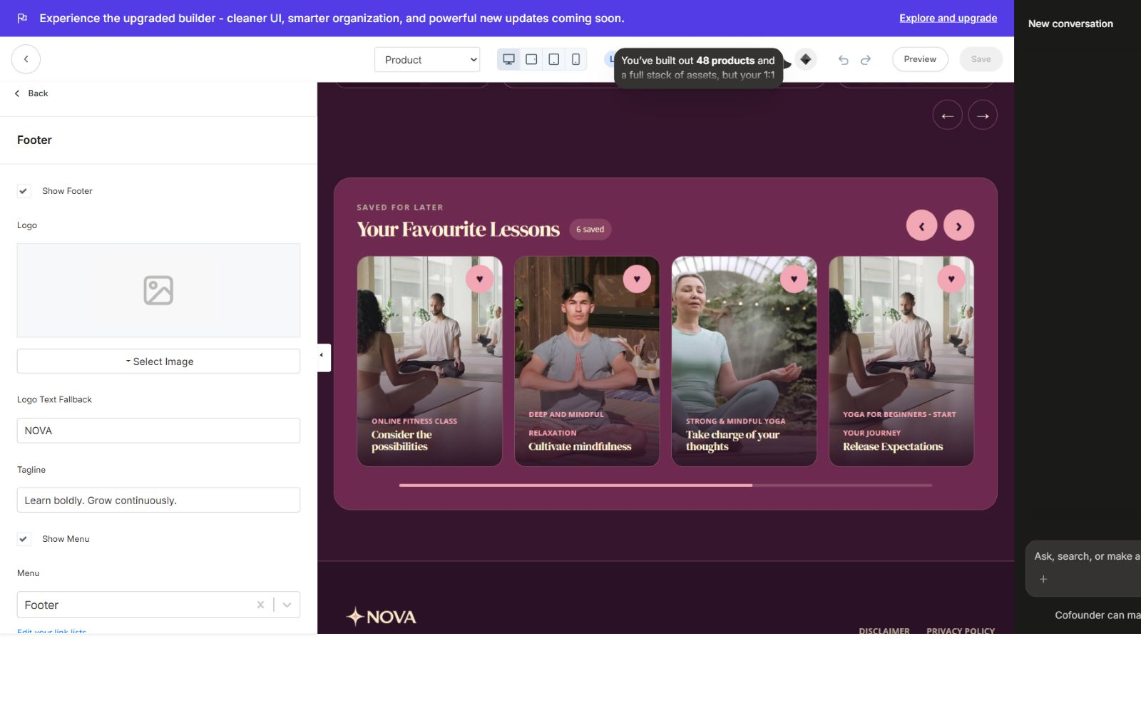
Footer controls: logo, tagline, menu, copyright and independent Powered by Kajabi visibility.
- Show/hide the complete footer, menu, copyright and Powered by Kajabi link independently.
- Use a logo image or text fallback and connect a Kajabi footer link list.
- Edit course labels, CTA copy, progress language, locked messages and fallback descriptions from the backend.
- Visible editor content uses context-aware kjb-settings-id attributes, so Kajabi opens the correct section or block when clicked.
- Real Kajabi content remains authoritative; fallback copy only fills incomplete or placeholder content.
PRODUCTION ARCHITECTURE
The active production assets are nova-theme-20260826.css and scripts.js. The uniquely named CSS asset helps avoid older Kajabi/CDN cache masking a theme update. Local storage is used only for the theme’s favourite-lesson presentation when Kajabi state is not immediately available.

Production test checklist
Run this checklist after every major branding or layout change.
Area | What members get | Backend control
Install | Theme card is valid, active and opens Customize | Upload ZIP unchanged
Desktop home | Hero clears header; no blank bottom block; cards and dots align | Test all 5 hero + 3 home layouts
Categories | Course hero, module cards, progress and access states render | Test both page layouts
Category | Breadcrumb, Up Next and lesson grid work | Test both page layouts + pagination
Lesson | Video/audio/resources/comments/assessment load | Test complete, save, Previous/Next
Search | Suggestions are visible before typing and filter live | Test matching and empty states
Mobile | Bottom nav and slide-up panels appear on every course page | Test lesson vs non-lesson behavior
Access | Lock, paywall and drip cards show correct icon and do not open | Test with restricted member

Final release checks
- Test with a real member who has incomplete, completed, locked, paywalled and drip-scheduled content.
- Verify links, Kajabi actions, Explore More destination and category switching.
- Check contrast after changing the four global colors.
- Confirm logo, favicon, typography and H1/H2/H3 sizes on desktop and mobile.
- Confirm the Community Widget stays hidden when disabled and respects selected height/width when enabled.
- Confirm Powered by Kajabi matches the desired footer setting.

— 14 / SOMASTREAM GUIDE

Quick reference
A compact handoff sheet for site owners and support teams.

Key defaults
Product Home  Featured Categories | Categories Page  Cinematic Journey
Category Page  Cinematic Journey | Community Widget  Off
Package  nova-learning-kajabi-theme-1.0.1.zip | Edition  Advanced Themes

Where to change common items
Area | What members get | Backend control
Colors | Theme Settings → Colors | 4 global controls
Fonts & sizes | Theme Settings → Typography | Body/Heading + Body/H1/H2/H3 px
Hero | Product → Cinematic Hero | 5 layouts
Home structure | Product → Product Syllabus | 3 layouts + favourites
Explore More | Product → Product Syllabus | Editable text + Kajabi action
Search/announcements | Product → Header / Search | Visibility + editable labels
Categories | Categories → All Categories | 2 layouts
Category | Category → Category | 2 layouts
Community | Product → Community Widget | Off, height, width, circle
Footer credit | Footer → Show Powered by Kajabi | Independent toggle

HANDOFF NOTE
Keep the original ZIP as the distribution master. If a future release is upgraded, retain the same folder structure and version the existing package instead of creating random parallel ZIPs.

SOMASTREAM
A cinematic home for
your Kajabi course.
Version 1.0.1 • Advanced Theme

